OSMOSIS Faculty Trial - Rectors' Conference of Italian Universities
Once you follow the invite link https://www.osmosis.org/cohort-invite?id=6098&k=jIFCOw96R9WqcqfWwxg4UOO1STKEBEXU, you will arrive at a web page like this:
- Select Get Started:
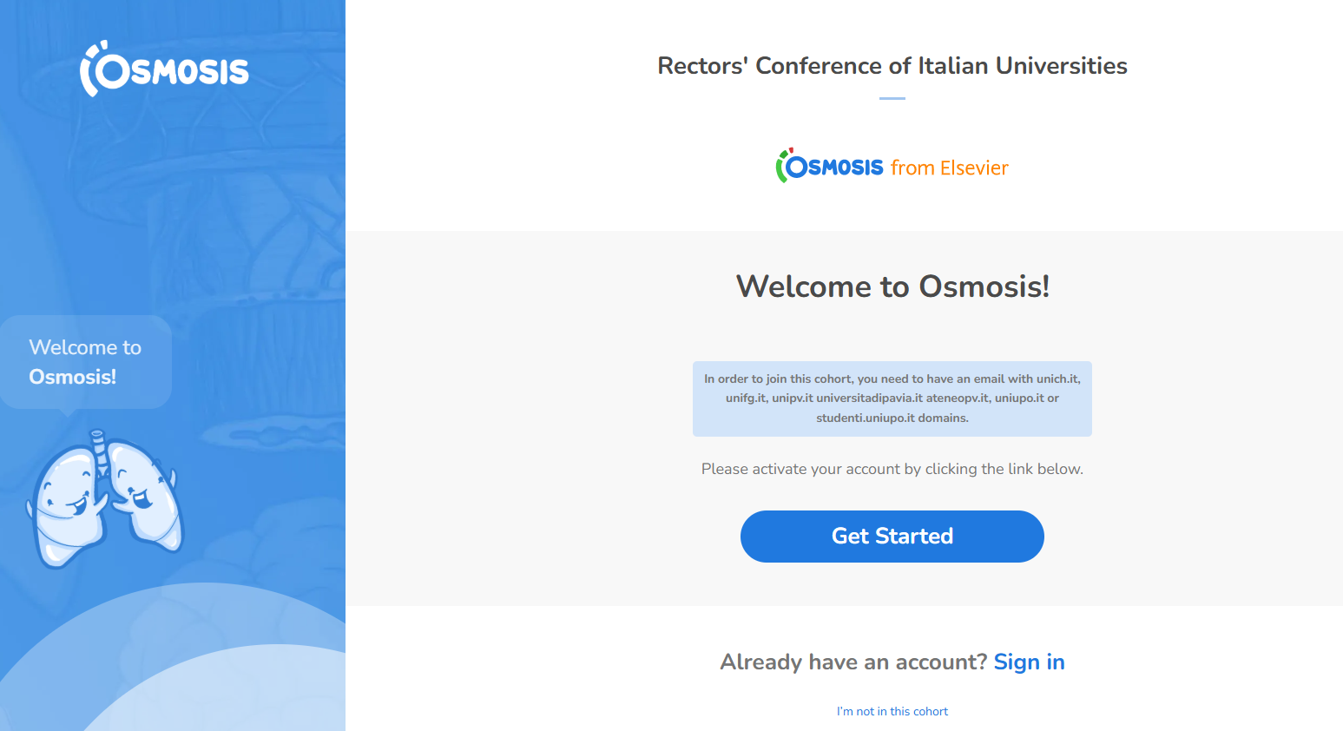
Select "Sign Up" to create a new account.
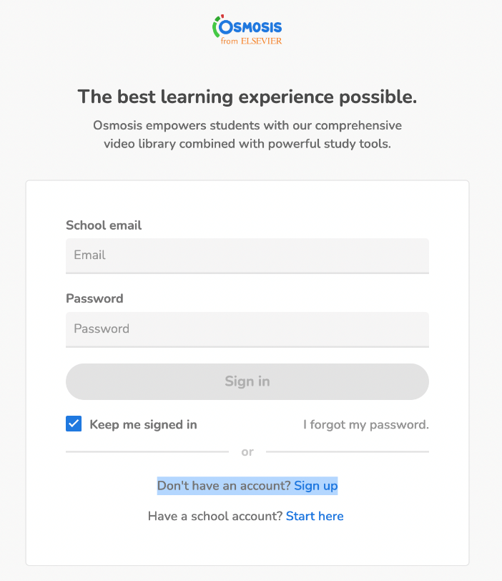

Finally, enter your email and set a password to create your account and activate your membership:
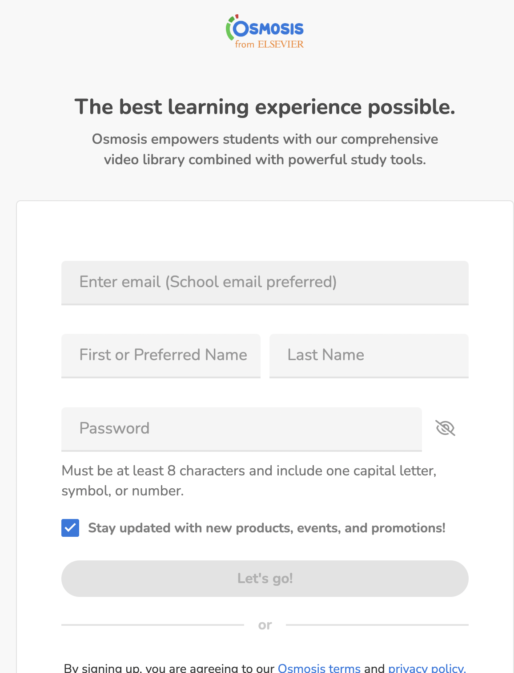

Users should use their school email address, only the following email domains have access to this trial unich.it, unifg.it, unipv.it, universitadipavia.it, ateneopv.it, uniupo.it or studenti.uniupo.it domains.
If the link doesn't work, or if you're being asked to log in it's most likely that you're not logged in on the email address that the subscription is registered to. If that's the case, log out of Osmosis, and log back in using a school email, then click the link again.
If you need any help, you can contact the Customer Experience team at support@osmosis.org, or click on the blue chat icon on the lower right hand corner of the screen.

